# Airtable account setup, API key generation and base ID generation

Section – 1: Airtable account setup and base creation

* 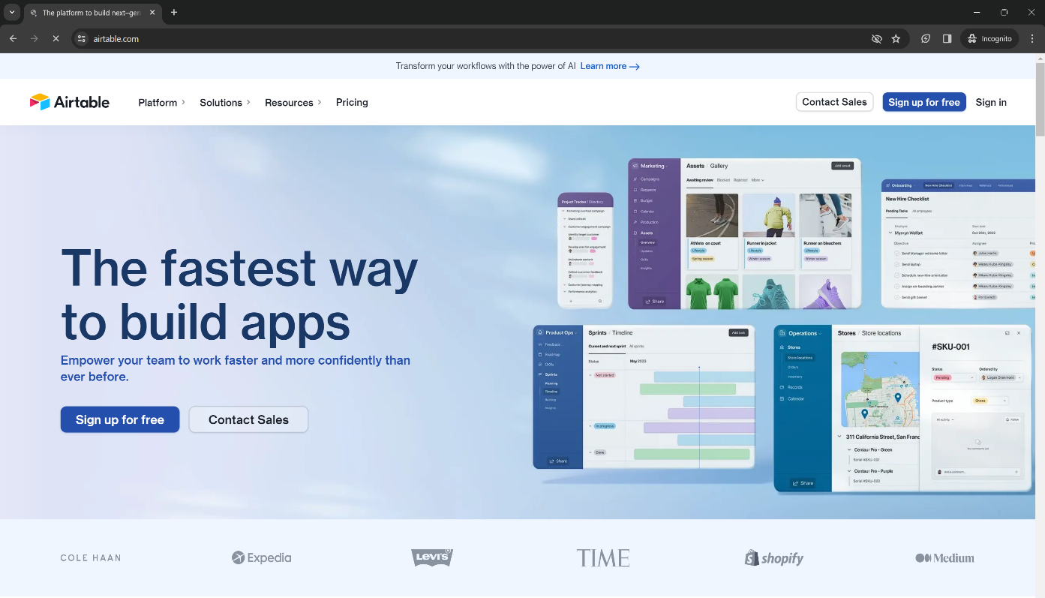Go to Airtable website: <https://www.airtable.com/>
* 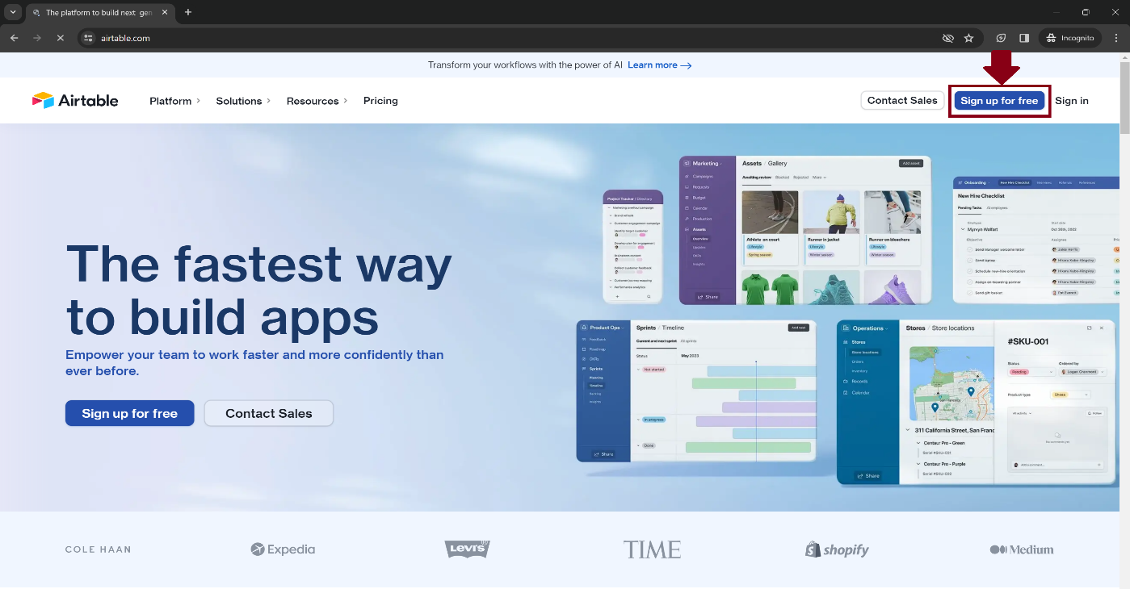Click on “Sign up for free” option.
* A screenshot of a login form

  Description automatically generatedSign up and verify with any of account you are comfortable with.
* A screenshot of a computer

  Description automatically generatedAfter signing in, you will be directed to the page below. Follow below steps and click on “Skip” option:

* A screenshot of a computer

  Description automatically generatedYou will be directed to the below dashboard page.
* A screenshot of a computer

  Description automatically generatedClick on Start from scratch in “My First Workspace”.
* 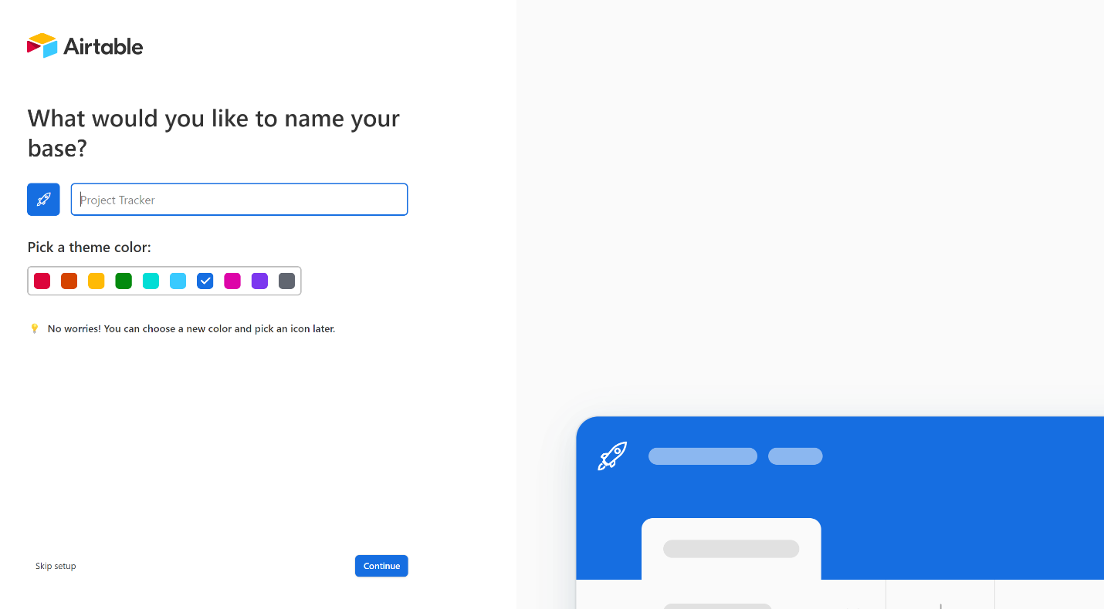You will be directed to the page below.
* 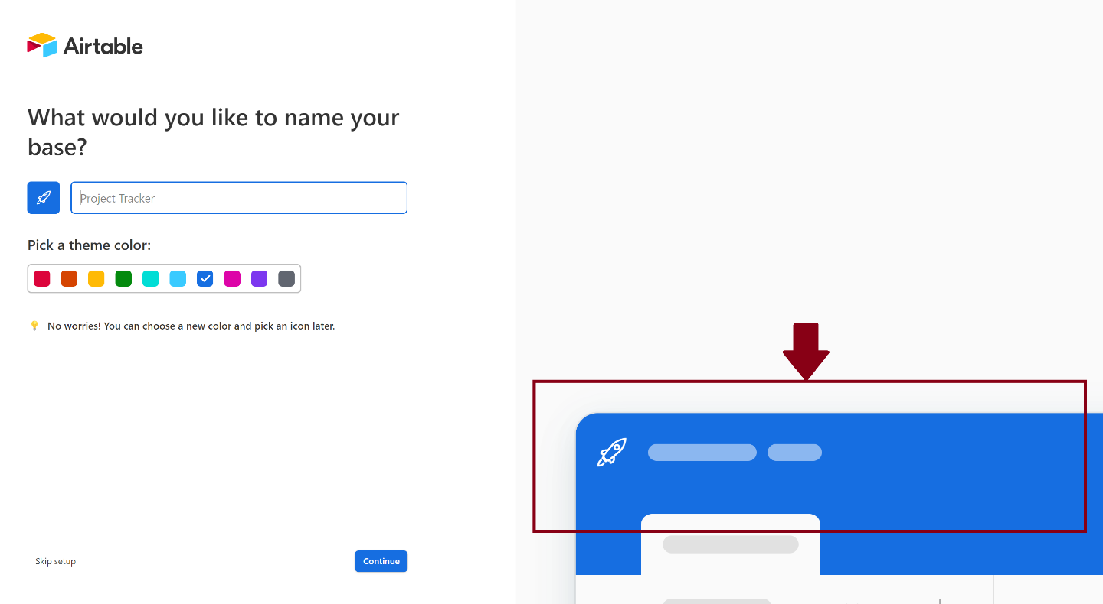**NOTE**: Right panel of web page shows whatever is being created or changes made while creating base. Make sure you check it before clicking on continue option every time.
* 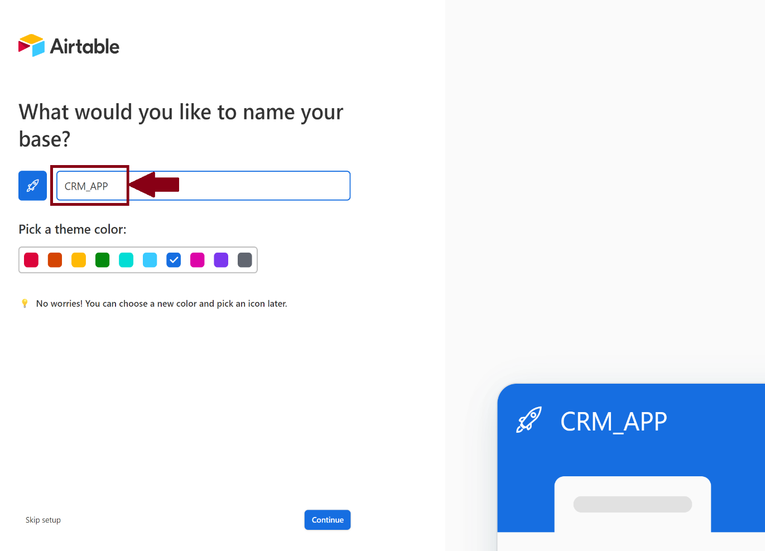Give appropriate name to the base being created and then click on “Continue” button.
* 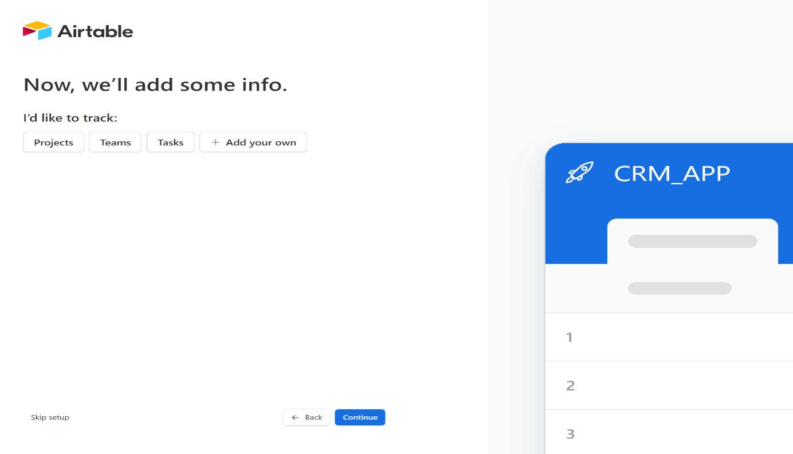You will be directed to the page below.
* A screenshot of a computer

  Description automatically generatedClick on “+Add your own” option to create table. Fill in fields to provide values of first column – “Name” automatically created and then click on continue.
* A screenshot of a computer

  Description automatically generatedYou will be directed to the page below.
* 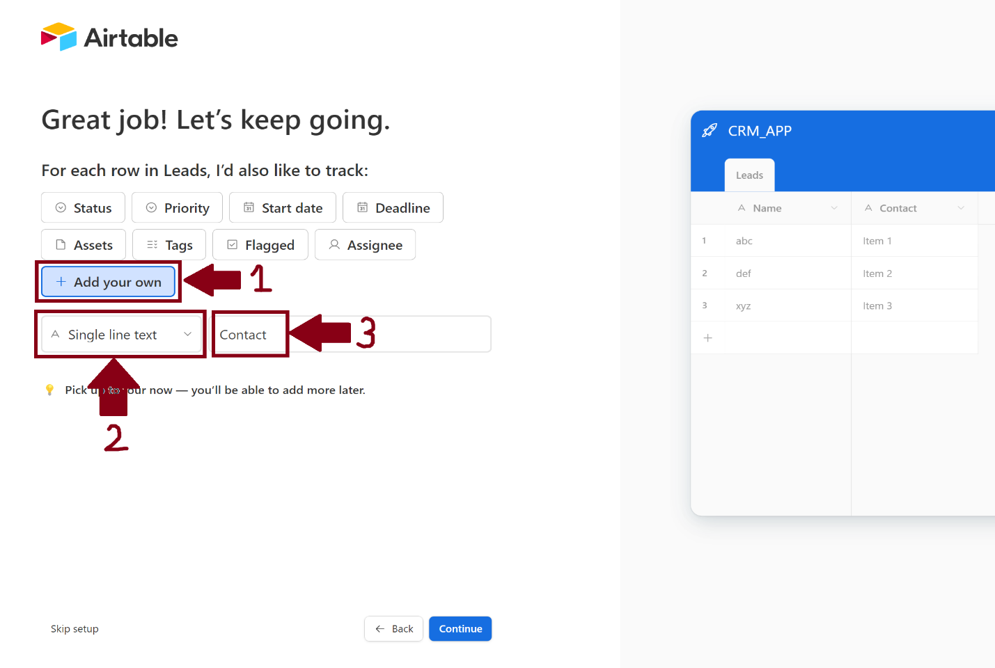Click on “Add your own”. Select “Single line text”. Write “Contact” in the beside empty field. Last, click on continue button.
* A screenshot of a computer

  Description automatically generatedYou will be directed to the page below.
* 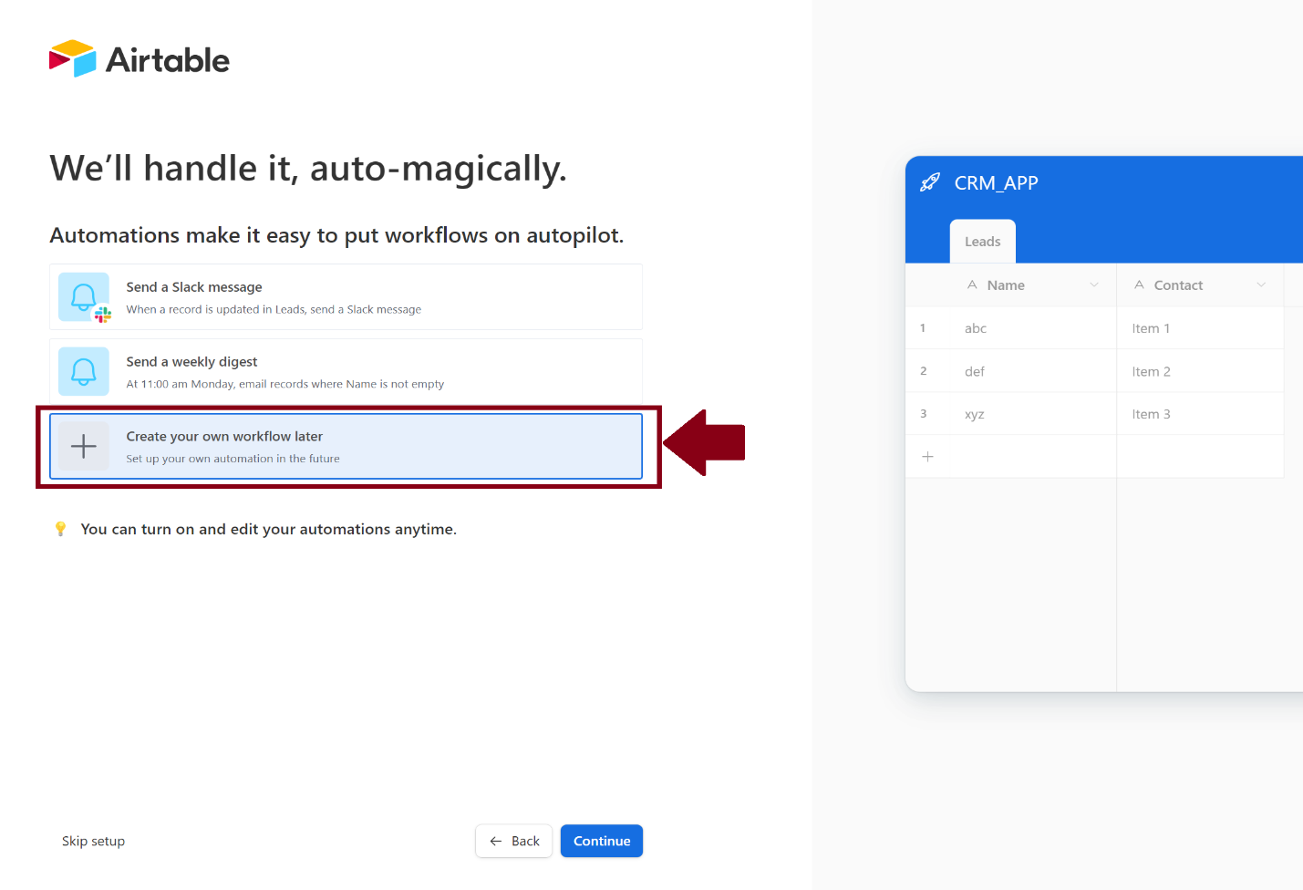Click on “Create our own workflow later” option and then click on continue button.
* A screenshot of a computer

  Description automatically generatedYou will be directed to the page below.
* 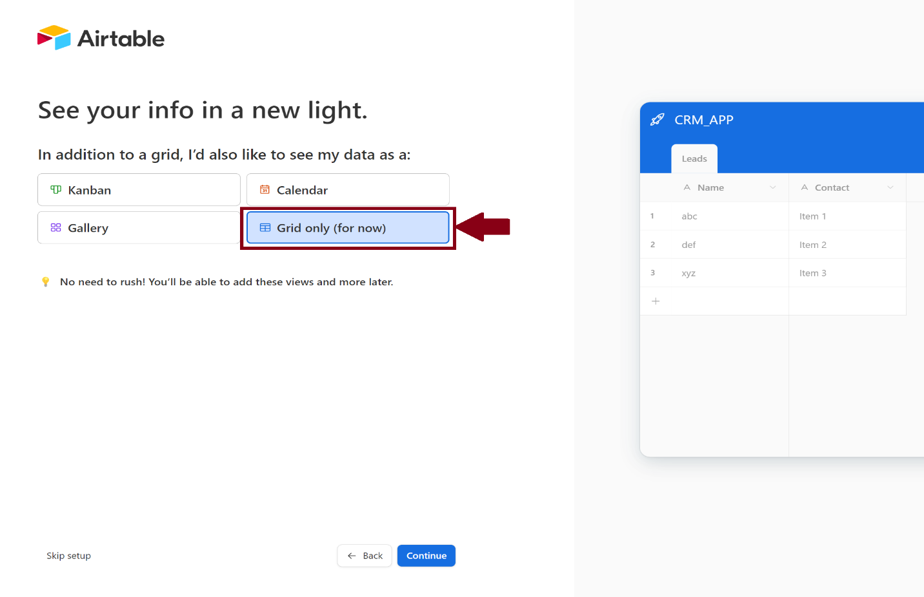Click on “Grid only (for now)” option and then click on continue button.
* A screenshot of a computer

  Description automatically generatedYou will be directed to the table created page.
* Click on “+” button beside Contact column to add Query column which is required to store query entered by user. Enter “Query” in field and select “Single line text” option. Click on “Create field” button. Query column will be created.

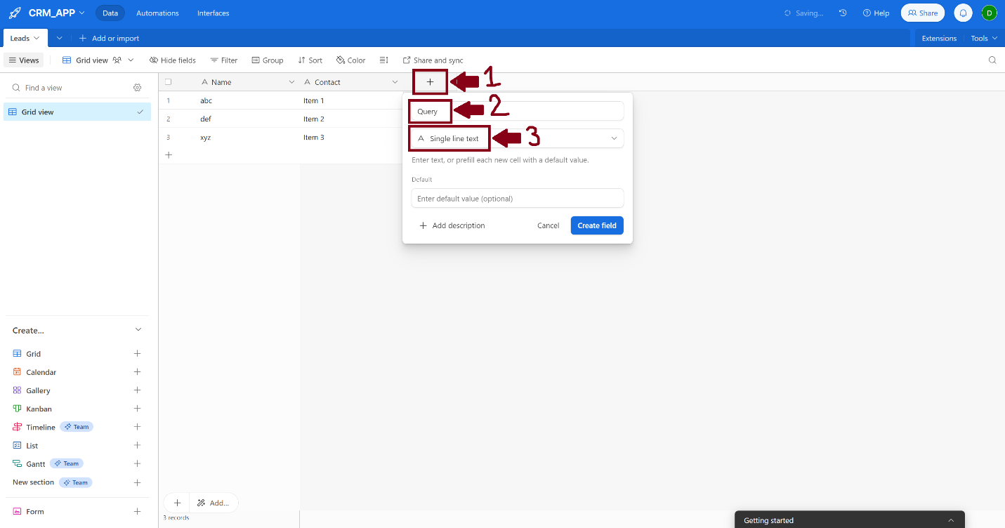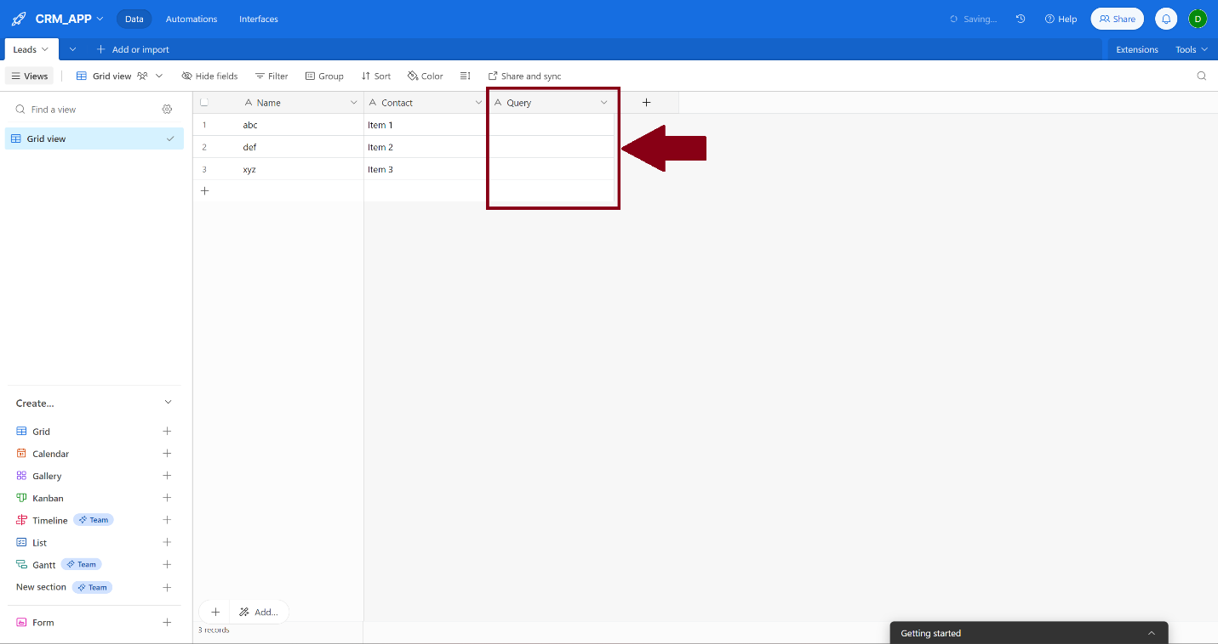

Section – 2: Airtable API key generation and base ID generation

* 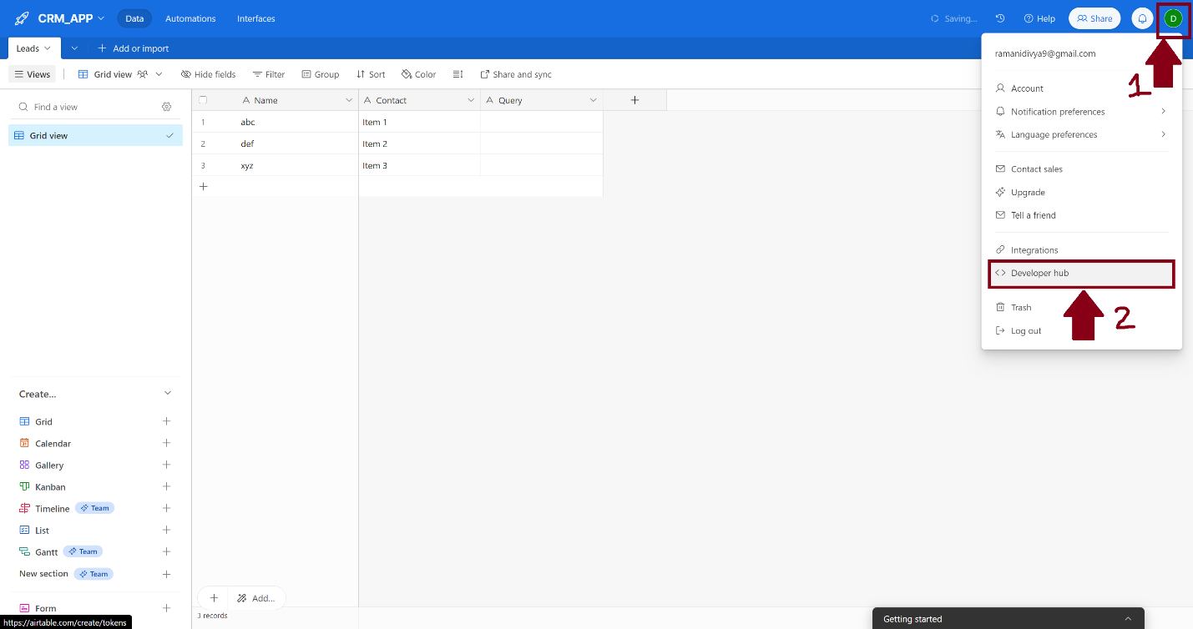Click on your airtable username icon beside the notification bell icon. Click on Developer hub option.

* You will be directed to the page below.
* A computer screen shot of a computer

  Description automatically generatedClick on “Create token” button in “Personal access tokens” page.
* 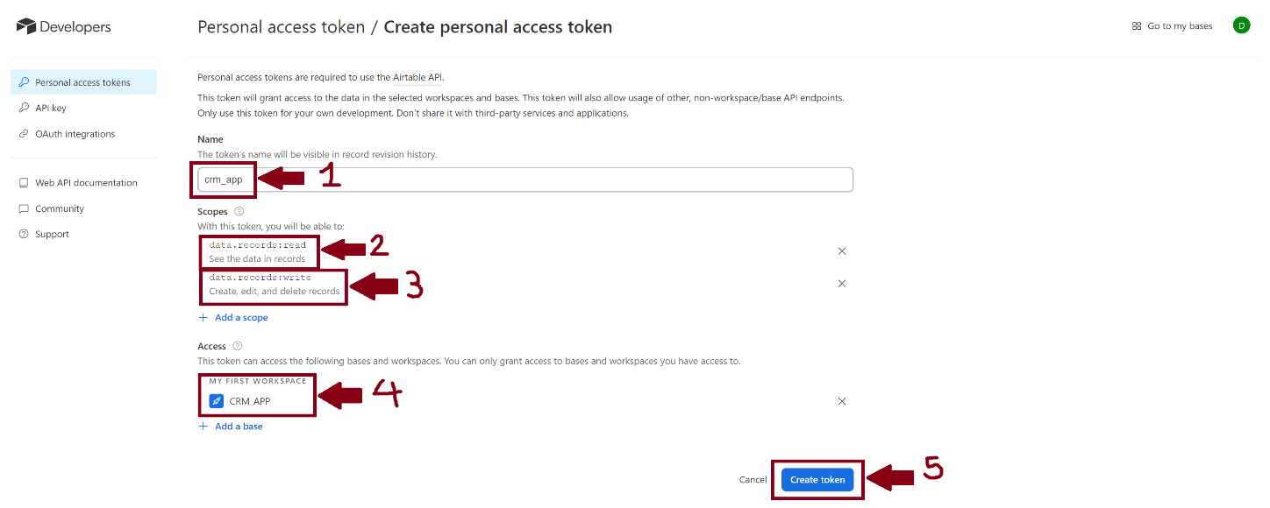Give appropriate name to the token being created. Select read and write scopes in “Scopes” section. Select base name in “Access” section. Click on “Create token” button.
* A screenshot of a computer

  Description automatically generated**NOTE**: Token generated right now will be visible once only in the dialogue appeared. Make sure you copy paste this token generated at some place for further use in code file.
* A white rectangular object with black text

  Description automatically generatedToken will be created, and you will be directed to the page below.
* 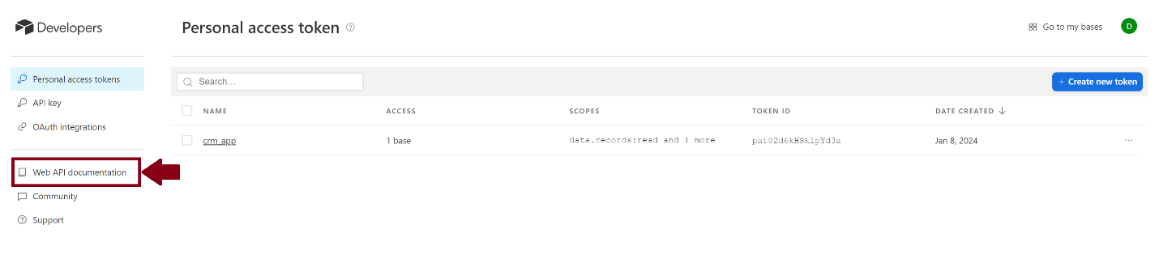Click on “Web ApI documentation” option on left panel – “Developers”.
* A screenshot of a computer

  Description automatically generatedYou will be directed to the page below.
* A screenshot of a computer

  Description automatically generatedClick on base name in API Reference page in Introduction section.
* 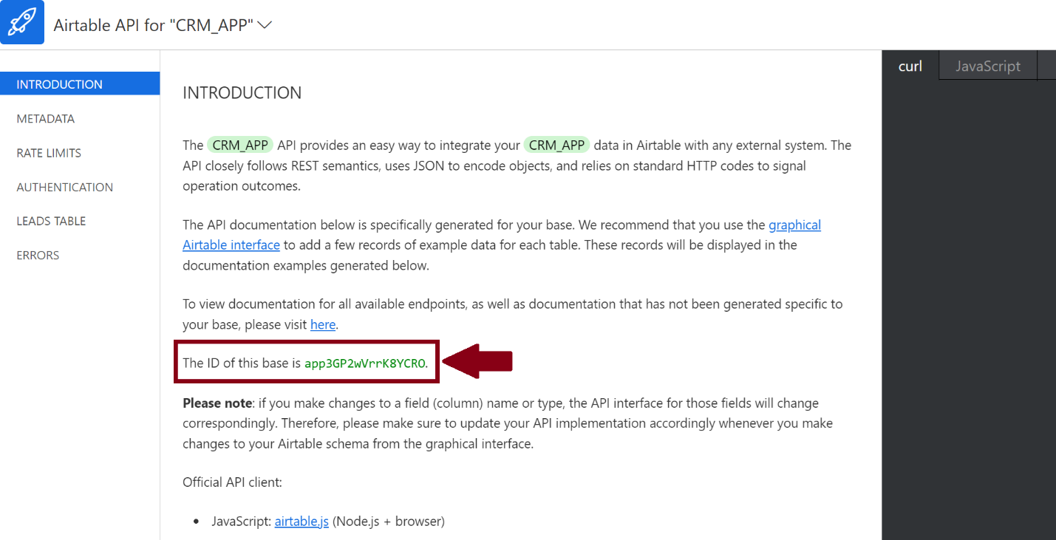Base ID will be available in “INTRODUCTION” section before note.